Dear Students & Parents with Heart @ Paakuma K-8,
February is national “Heart Month” and Paakuma’ K-8 wants to help fight the # 1 cause of death in our country, heart disease and stroke. 1 in 3 people will die of heart disease, yet it is 80% preventable. We will be holding a fun event during PE class because we want everyone to be a survivor of heart disease and stroke.
SURVIVORball for Heart March 10th
This will take place during our PE classes in the Paakuma’ gym. There is a $5 minimum donation to play and you will receive a lifesaver “Paintball Duck” and a lanyard. Anyone not wishing to participate will be able to do an alternate PE activity.
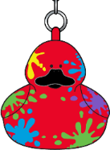
The donations our school raises will help fund lifesaving research, medicine, treatments and education. Almost all donations stay in our area and our school receives PE equipment.
DONATIONS DUE BACK: Friday, February 17th, 2016
Receive thank you gifts for collecting donations. All gifts are cumulative.

Receive a “PAINTBALL” Lifesaver Duck and a lanyard when you raise $5.
Raise donations easily; go online to: www.heart.org/schools. Email, Twitter & Facebook. Download the free App. Go to American Heart Association in your App Store and download Schools4heart app.
Check with your parent’s employer for matching gift forms to double your tax deductible donation.
Please make checks payable to: American Heart Association.
Raise $10 and receive a RED
“Life is Why” t-shirt.
YS, S, M, L, XL & XXL
Please specify size on envelope
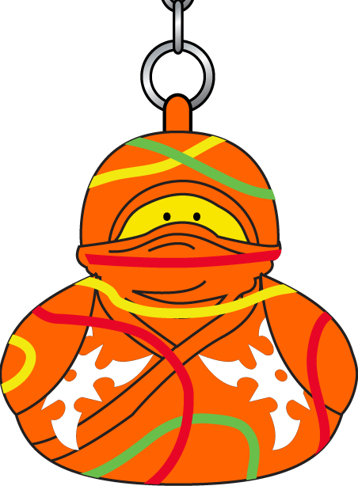
For every extra 5 bucks you raise, you get to pick a duck from the mystery lifesaver duck collection. First come first serve - maximum of 10 ducks.

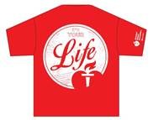

BONUS: Receive an “EXTRA LIVES CARD”. You will receive a punch card with extra lives on it. For every $10 you raise, you will earn an extra life in the game.
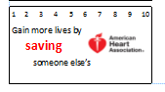

Heartfelt thanks,
Mr. Walters, Ms. Cajiuat and Mrs. Imbriani

